**EXPERIMENT NO. – 12**

**AIM:** To create a Lambda function which will log “An Image had been added” once you addd an object to a specific bucket in S3

**LO:** LO1:- To understand the fundamentals of Cloud Computing and be fully proficient with Cloud based DevOps solution deployment options to meet your business requirements

LO6:- To engineer a composition of nano services using AWS Lambda and Step Functions with the Serverless Framework

**THEORY:**

**AWS Lambda** is an [event-driven](https://en.wikipedia.org/wiki/Event-driven_programming), [serverless computing](https://en.wikipedia.org/wiki/Serverless_computing" \o "Serverless computing) platform provided by [Amazon](https://en.wikipedia.org/wiki/Amazon.com) as a part of [Amazon Web Services](https://en.wikipedia.org/wiki/Amazon_Web_Services). It is a computing service that runs code in response to [events](https://en.wikipedia.org/wiki/Event_(computing)) and automatically manages the computing resources required by that code. It was introduced on November 13, 2014.AWS Lambda was designed for use cases such as image or object [uploads](https://en.wikipedia.org/wiki/Upload) to [Amazon S3](https://en.wikipedia.org/wiki/Amazon_S3), updates to [DynamoDB](https://en.wikipedia.org/wiki/DynamoDB" \o "DynamoDB) tables, responding to website clicks, or reacting to sensor readings from an [IoT](https://en.wikipedia.org/wiki/Internet_of_Things" \o "Internet of Things) connected device. AWS Lambda can also be used to automatically provision back-end services triggered by custom [HTTP requests](https://en.wikipedia.org/wiki/HTTP_request), and "spin down" such services when not in use, to save resources. These custom HTTP requests are configured in AWS API Gateway, which can also handle [authentication](https://en.wikipedia.org/wiki/Authentication) and [authorization](https://en.wikipedia.org/wiki/Authorization) in conjunction with [AWS Cognito](https://en.wikipedia.org/wiki/Amazon_Cognito).

Amazon Simple Storage Service (Amazon S3) is an object storage service offering industry-leading scalability, data availability, security, and performance. Customers of all sizes and industries can store and protect any amount of data for virtually any use case, such as data lakes, cloud-native applications, and mobile apps. With cost-effective storage classes and easy-to-use management features, you can optimize costs, organize data, and configure fine-tuned access controls to meet specific business, organizational, and compliance requirements.Amazon S3 or Amazon Simple Storage Service is a service offered by [Amazon Web Services](https://en.wikipedia.org/wiki/Amazon_Web_Services) (AWS) that provides [object storage](https://en.wikipedia.org/wiki/Object_storage) through a [web service](https://en.wikipedia.org/wiki/Web_service) interface. Amazon S3 uses the same scalable storage infrastructure that [Amazon.com](https://en.wikipedia.org/wiki/Amazon_(company)) uses to run its e-commerce network.Amazon S3 can store any type of object, which allows uses like storage for Internet applications, backups, disaster recovery, data archives, [data lakes](https://en.wikipedia.org/wiki/Data_lake) for analytics, and [hybrid cloud storage](https://en.wikipedia.org/wiki/Cloud_computing#Hybrid_cloud).Amazon S3 manages data with an [object storage](https://en.wikipedia.org/wiki/Object_storage) architecture which aims to provide [scalability](https://en.wikipedia.org/wiki/Scalability), [high availability](https://en.wikipedia.org/wiki/High_availability), and [low latency](https://en.wikipedia.org/wiki/Low_latency) with high [durability](https://en.wikipedia.org/wiki/Durability_(database_systems)" \o "Durability (database systems)).The basic storage units of Amazon S3 are objects which are organized into buckets. Each object is identified by a unique, user-assigned key.[[7]](https://en.wikipedia.org/wiki/Amazon_S3#cite_note-7) Buckets can be managed using the console provided by Amazon S3, programmatically with the AWS [SDK](https://en.wikipedia.org/wiki/Software_development_kit), or the [REST](https://en.wikipedia.org/wiki/Representational_State_Transfer) application programming interface. Objects can be up to five [terabytes](https://en.wikipedia.org/wiki/Terabyte) in size.Requests are authorized using an [access control list](https://en.wikipedia.org/wiki/Access_control_list) associated with each object bucket and support [versioning](https://en.wikipedia.org/wiki/Versioning_file_system)[[10]](https://en.wikipedia.org/wiki/Amazon_S3#cite_note-10) which is disabled by default.[[11]](https://en.wikipedia.org/wiki/Amazon_S3#cite_note-11) Since buckets are typically the size of an entire file system mount in other systems.

**Output:-**

1. Create a lambda function

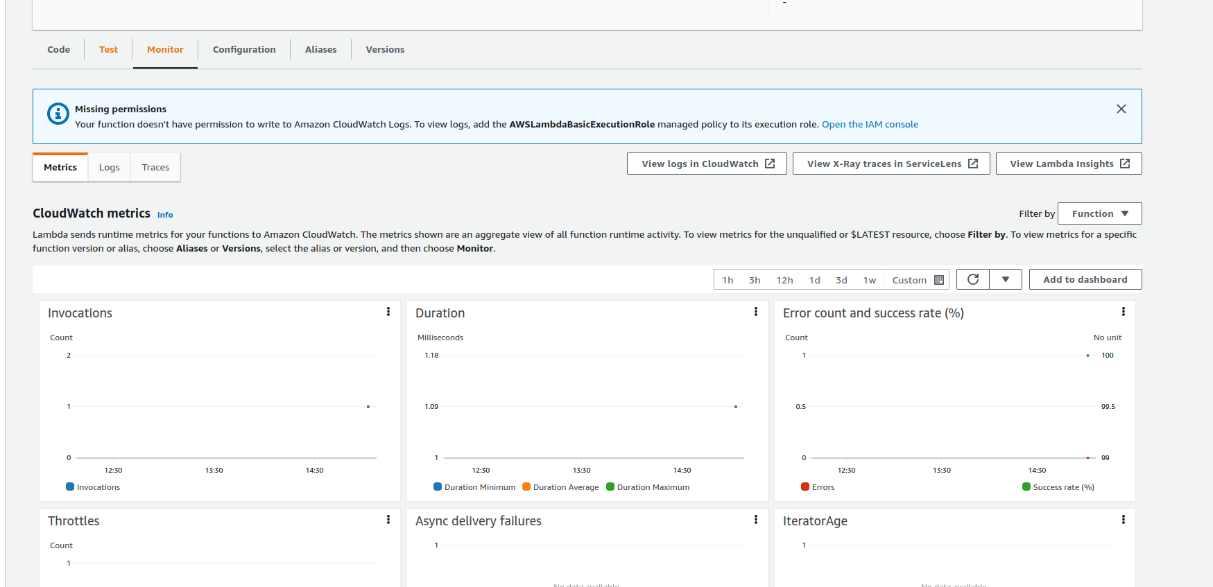

2) Create a S3 bucket

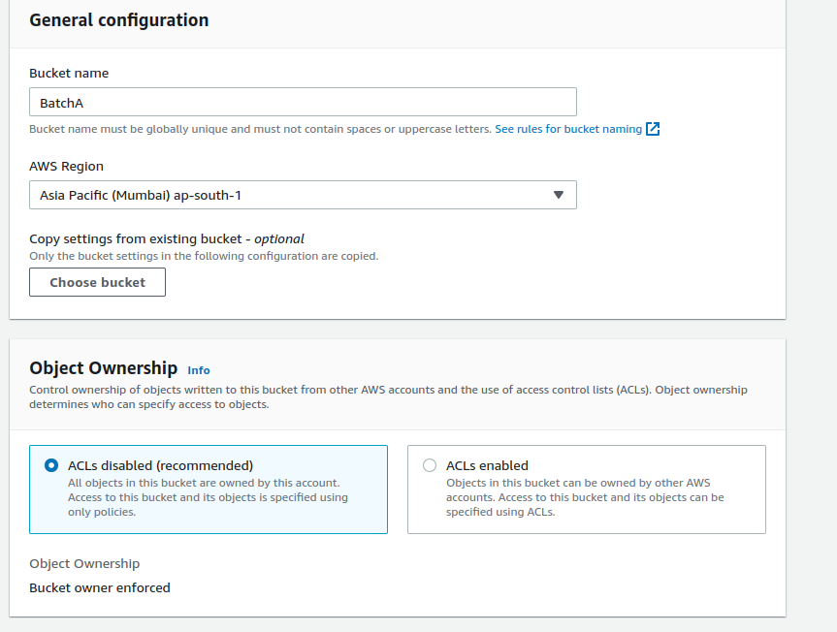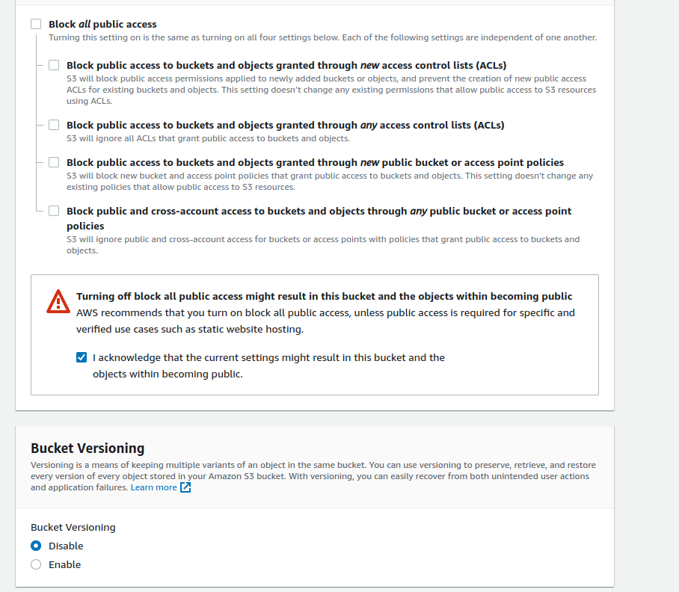

3) Create a trigger in the S3 bucket

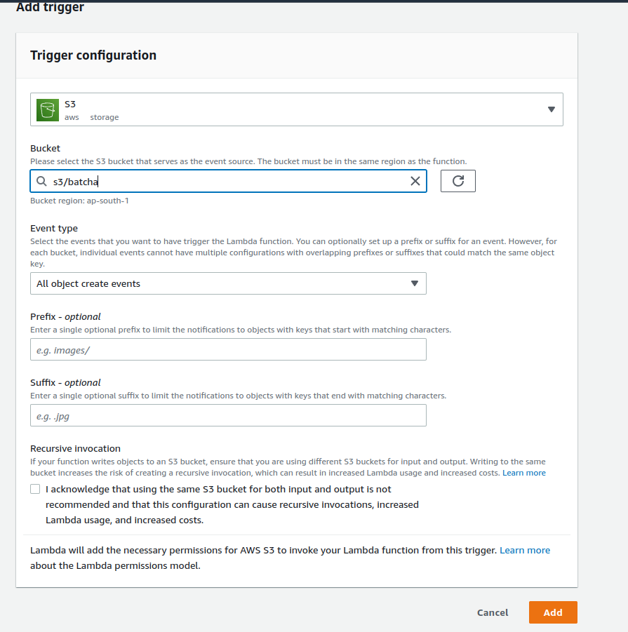

4) our bucket is created

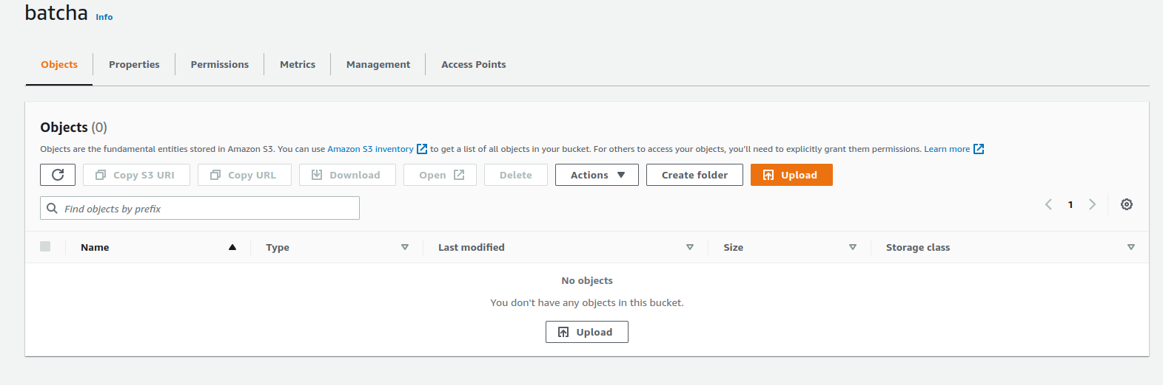

5) upload a file in the bucket

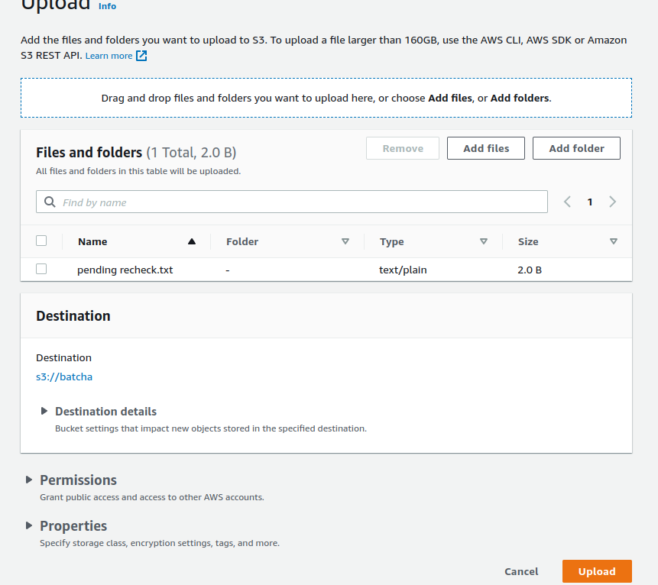

6) file is uploaded

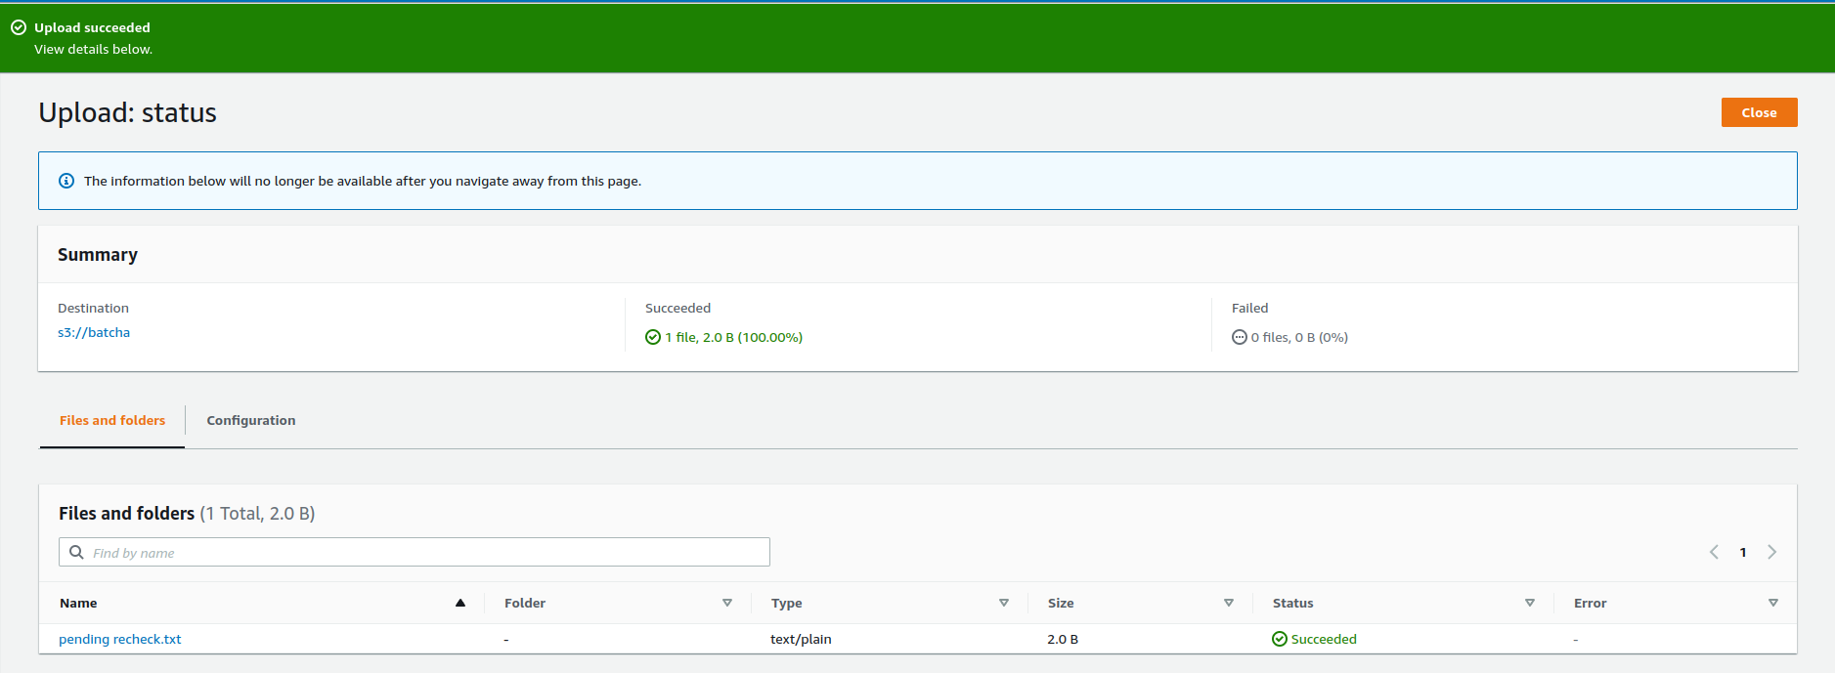

7) adding the S3 bucket

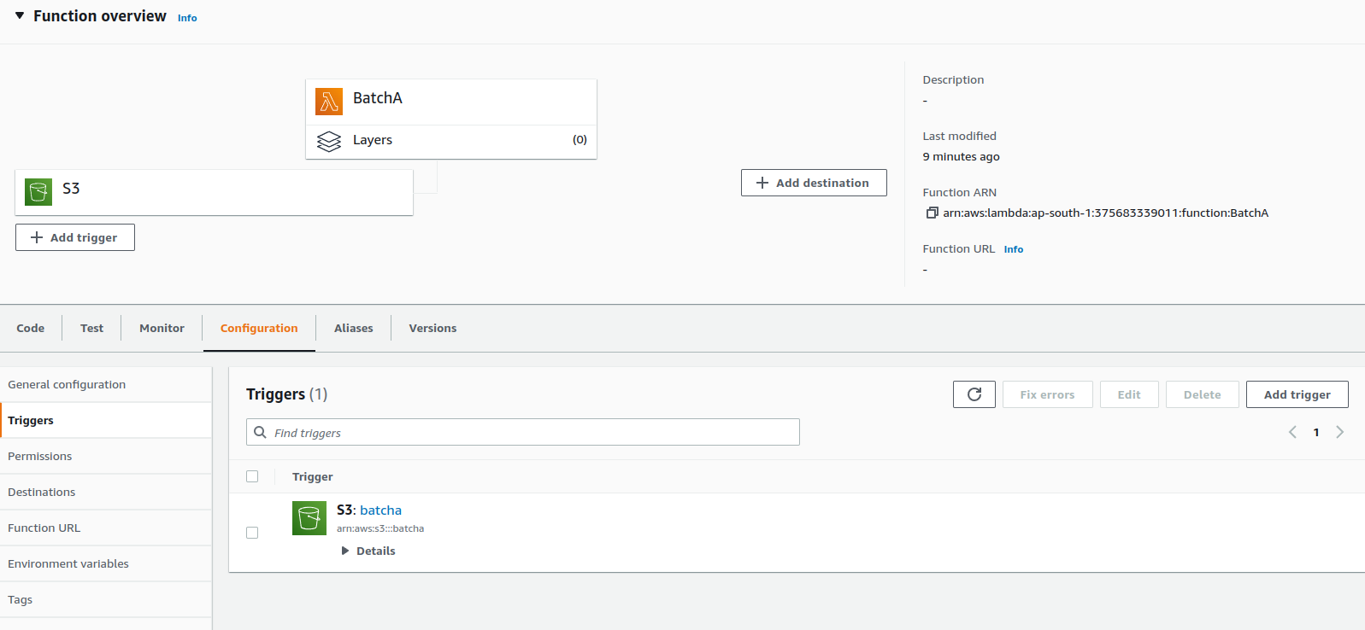

8) checking the logs to see the bucket events

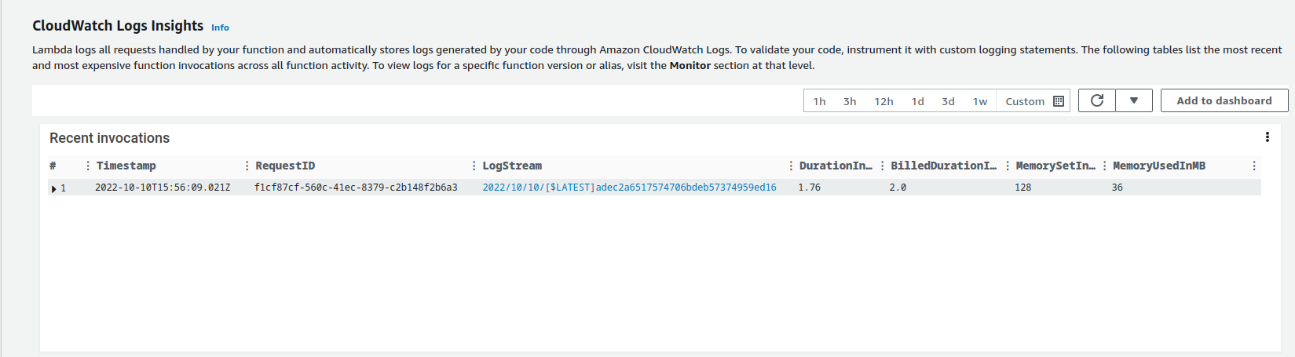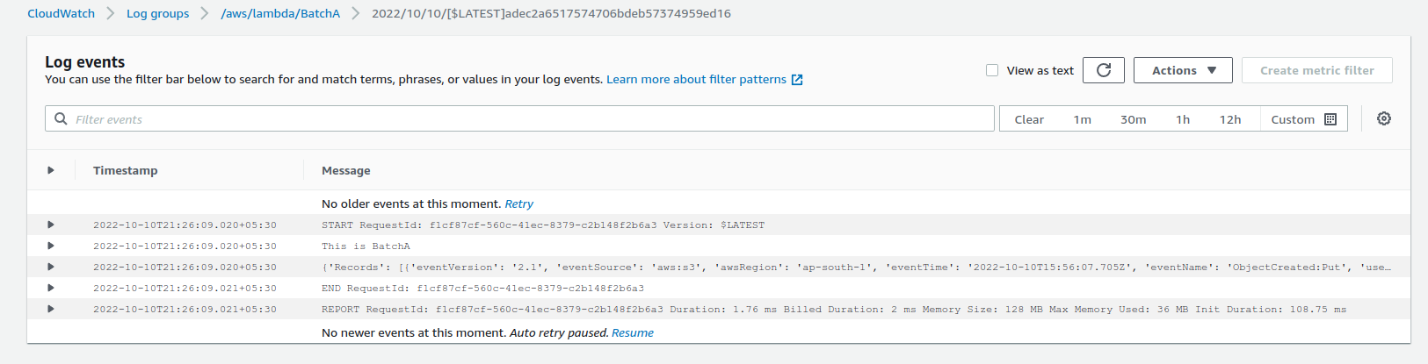

**Conclusion:-**